Gym Exercises System – Website Report
- Website Overview
The Gym Exercises System is a simple website designed to help users learn different gym exercises, follow weekly workout plans, and track their fitness progress. The website includes multiple pages such as Home, About, Exercises, Workout Plans, and Contact. Each page is connected through a navigation menu, making it easy for users to move between sections.
- Updates to Sitemap/Layout
No major changes were made to the original sitemap. The structure remains simple and organized with five main pages. Minor improvements were made by adding images and improving layout design to enhance user experience.
- Page and Content Updates
The content was updated to include:
- Detailed exercise tables with muscle groups and difficulty levels
- A weekly workout plan table
- A progress tracking table
- A contact form with multiple input fields
- Images related to exercises such as bench press, squat, and deadlift
- Screenshots and Description of Pages
- Home Page: Displays the website title and a welcome message introducing the system.
- About Page: Provides information about the website and includes an email link for contact.
- Exercises Page: Shows a structured table of exercises categorized by muscle groups, along with images.
- Workout Plans Page: Contains a weekly workout schedule in table format.
- Contact Page: Includes a form that collects user input such as name, email, age, and fitness goals.
- 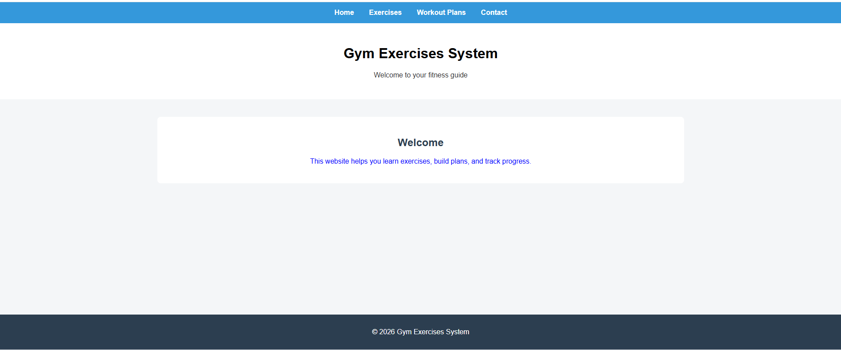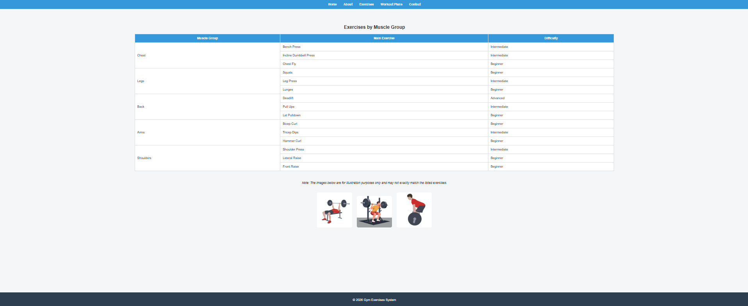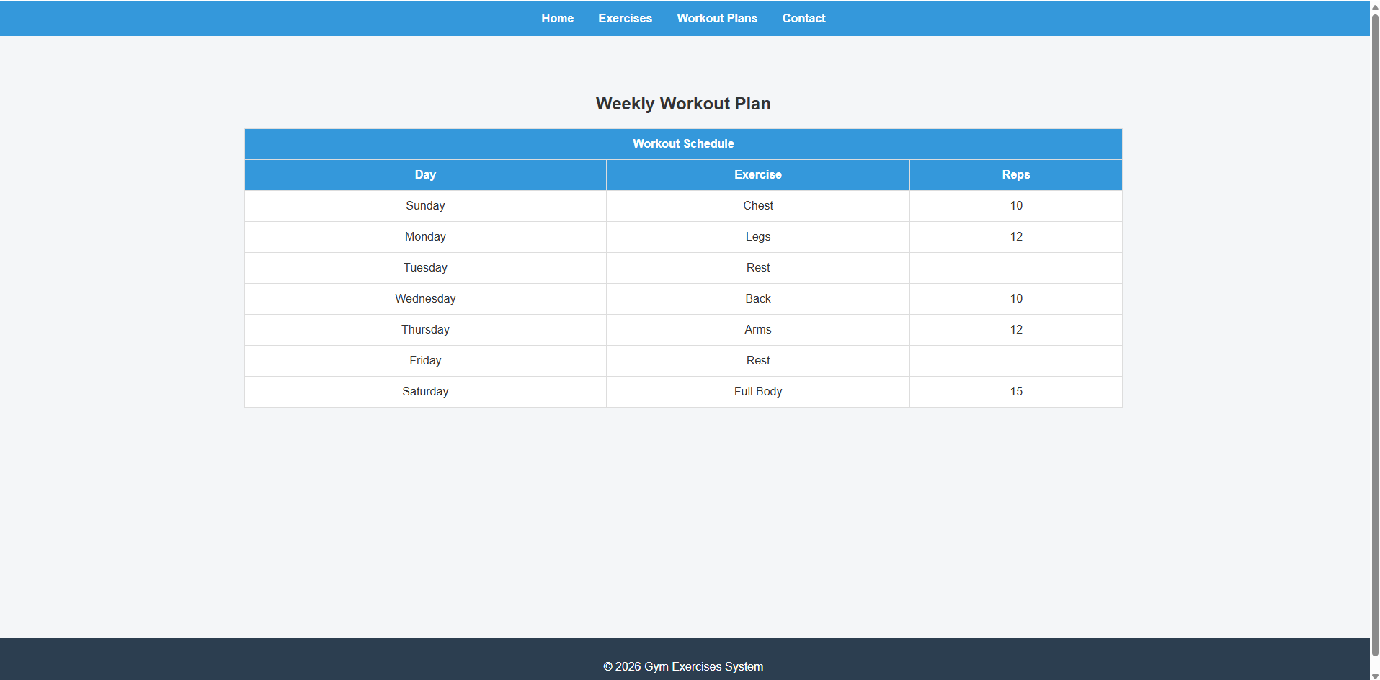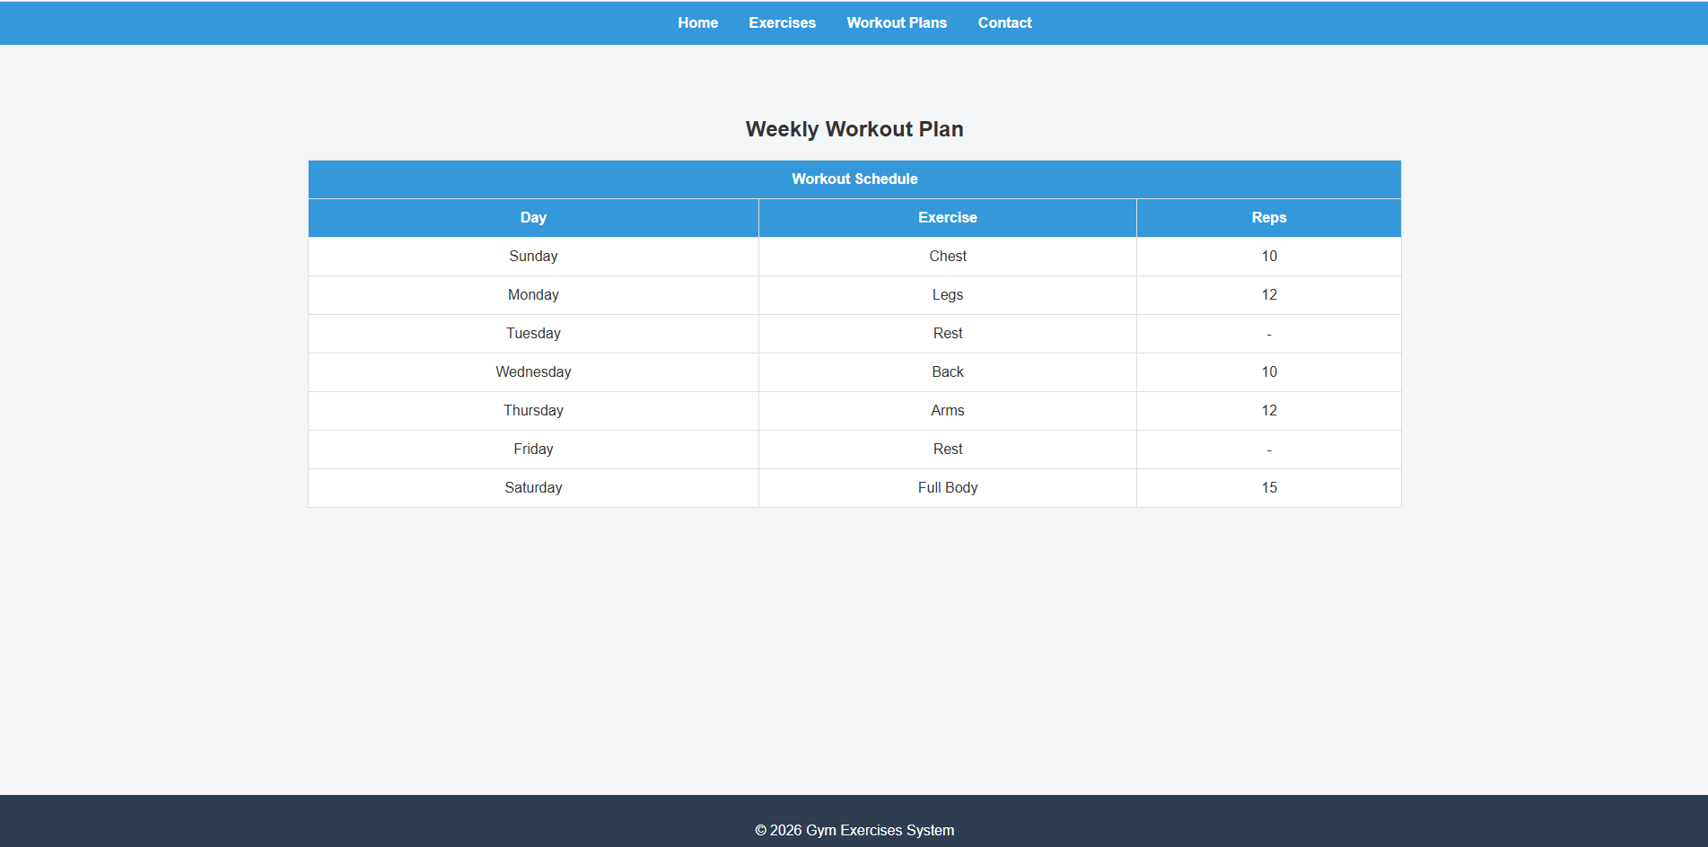
- CSS Styling
CSS styling is applied using three methods:
- External CSS: Used for layout, tables, navigation bar, and overall design (style.css).
- Internal CSS: Used within a page to style headings.
- Inline CSS: Used directly on elements for specific styling (e.g., paragraph color).
Different CSS selectors were used including element, class, id, group, descendant, attribute, and pseudo-class selectors.
- Website Links
Hosting link: (To be added after publishing)
GitHub repository link: (To be added after uploading project)
- Team Contributions
Each team member contributed to different parts of the project including design, coding, and testing. Tasks were divided to ensure all requirements were completed efficiently.

